IGCSE CIE Maths  1 hour  20 questions
Calculator Questions

Set Notation & Venn Diagrams
Set Notation & Venn Diagrams

Easy (3 questions) /9

Medium (6 questions) /17

Hard (6 questions) /19

Very Hard (5 questions) /27

Total Marks /72

Scan here to return to the course
or visit savemyexams.com
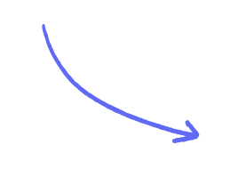

Easy Questions

1 (a)
ℰ = {21, 22, 23, 24, 25, 26, 27, 28, 29, 30}

A = {22, 24, 26, 28, 30}

B = {21, 24, 27, 30}

List the members of the set

i)

ii)
A ∩ B

A'

[1]

[1]

(2 marks)

(b) C = {23, 25, 29}

Using set notation, ﬁnd an expression for C in terms of A and B .

(1 mark)

2 (a)
ℰ= {letters of the alphabet}
B = {b, r, a, z, i, l}
I = {i, r, e, l, a, n, d}

List the members of the set

i)

ii)
B ∪ I B ∩ I ʹ

[1]

[1]

(2 marks)

(b) K = {k, e, n, y, a}

Cody writes down the statement B ∩ K = ∅
Cody’s statement is wrong. Explain why.

(1 mark)

3 (a)
B ={b,l,u,e}
G ={g,r,e,y}
W ={w,h,i,t,e}

List all the members of the set

i)

ii)
B ∪ G W ∩ G'

[1]

[1]

(2 marks)

(b) Serena writes down the statement B ∩ G ∩ W = ∅
Is Serena’s statement correct?
You must give a reason for your answer.

[1]

(1 mark)

Medium Questions
- There are 32 students in a class.

5 do not study any languages. 15 study German (G).
18 study Spanish (S).

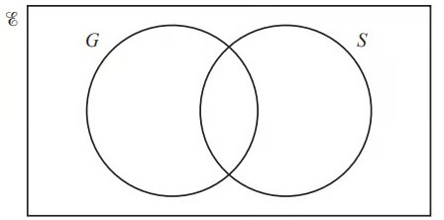

Complete the Venn diagram to show this information.

(2 marks)

- (a) x is an integer.

ℰ ={x : 41 ≤ x ≤ 50}

A ={x : x is an odd number}

B ={x : x is a multiple of 3}

C ={x : x is a prime number}
Complete the Venn diagram to show this information.
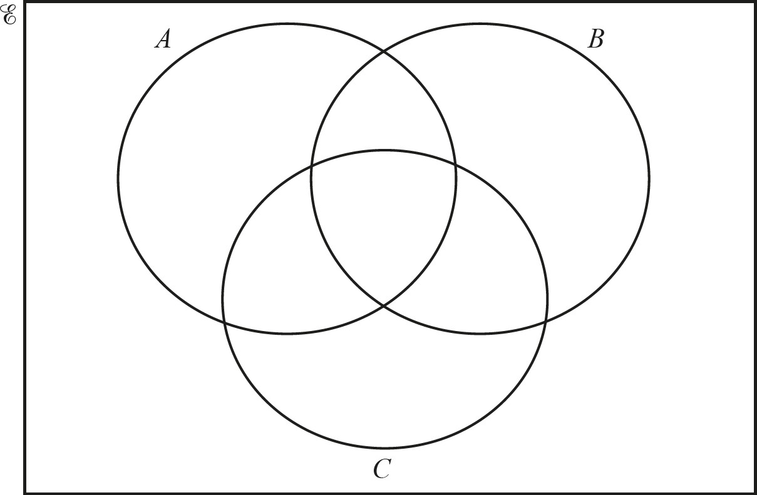

(3 marks)

  - List the elements of
    - A ∩ C,

(B ∪ C)'.
[1]

[1]

(2 marks)

  - Find n(A ∩ B ∩ C) .

(1 mark)

- (a) ℰ= {students in a school}
F = {students who play football}
B = {students who play baseball}

There are 240 students in the school.

- 120 students play football
- 40 students play baseball
- 90 students play football but not baseball.
Complete the Venn diagram to show this information.

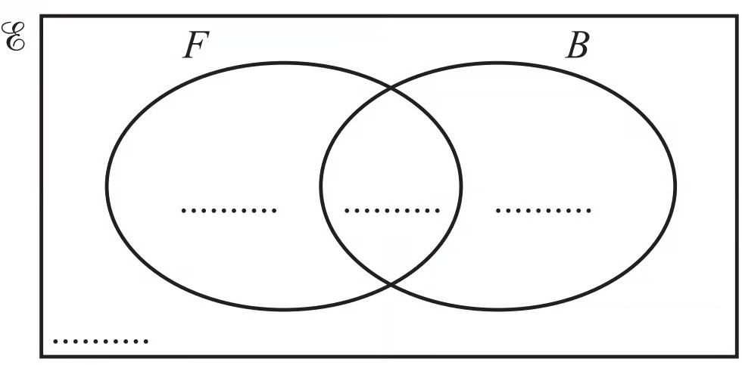

(2 marks)

(b) Find n (F '∩ B') .

(1 mark)

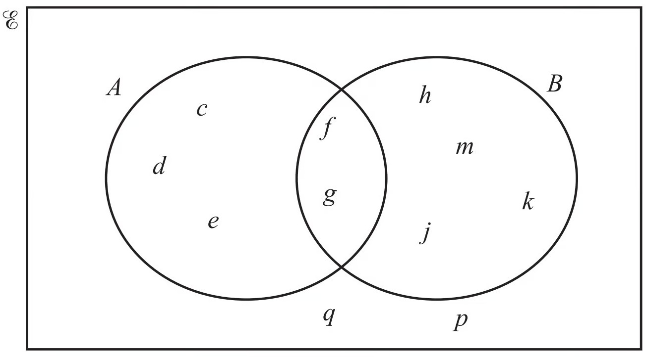
- Use set notation to complete the statements.
i) d A

ii)

iii)

{f , g} = ...............................

Complete the statement.
[1]

[1]

n( ) = 6 [1]

(3 marks)

- In the Venn diagram below, shade C ∩ D'.

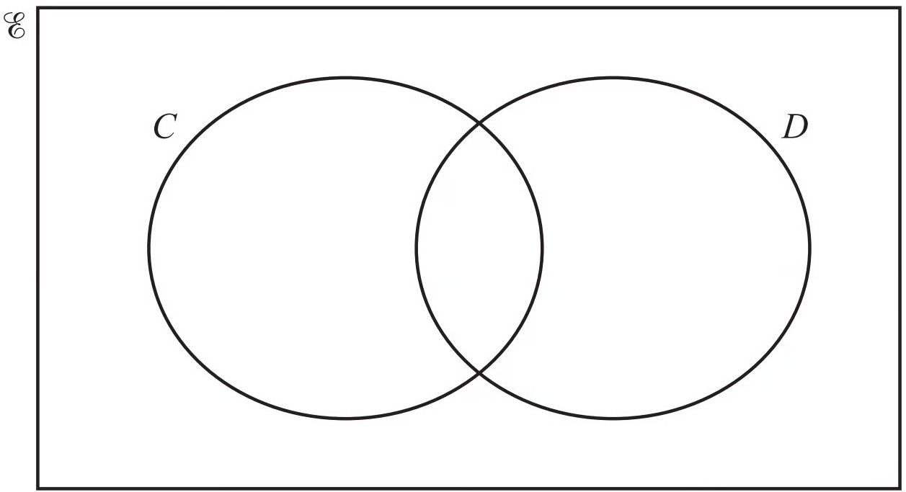

(1 mark)

- The number of members of a leisure centre using the exercise machines (E), the swimming pool (S) and the tennis courts (T) is shown on the Venn diagram.

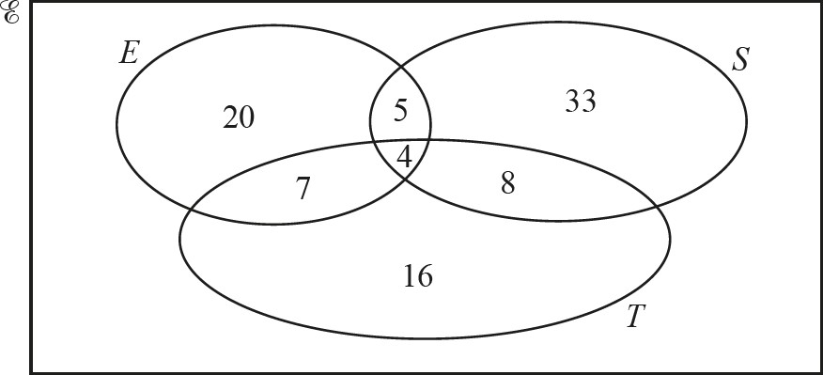

i) Find the number of members using only the tennis courts.

ii)

Find the number of members using the swimming pool.
[1]

[1]

(2 marks)

Hard Questions

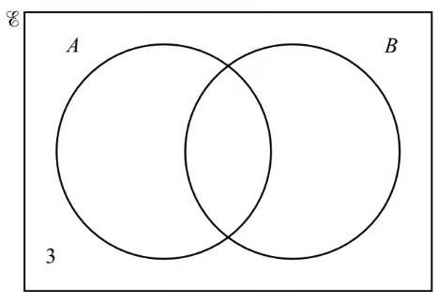
1 (a) n(ℰ) = 20, n(A ∪ B)' = 3, n(A) = 10 and n(B) = 13.
The Venn diagram shows some of this information.

Find n(A ∩ B)

(2 marks)

(b) n(A′ ∩ B) .

(1 mark)

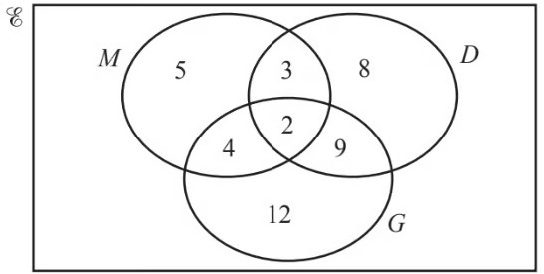

2 (a)

The Venn diagram above shows information about the number of students who study Music (M), Drama (D) and Geography (G).

i) How many students study Music?

ii)

How many students study exactly two subjects?
[1]

[1]

(2 marks)

(b) In the Venn diagram above, shade M ∩ D'.

(1 mark)

3 (a) ℰ={x : x is an integer and 1 ≤ x ≤ 10}
A ={x : x is even} 4 ∈ A ∩ B
n(A ∩ B) = 1
(A ∪ B)'={1,7,9}

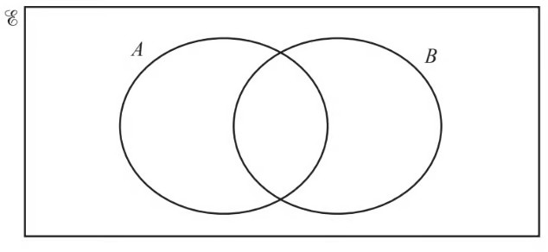
Complete the Venn diagram using this information.

(4 marks)

- Use your Venn diagram to complete the statement.

B ={ }

(1 mark)

4 The number of members of a leisure centre using the exercise machines (E), the swimming pool (S) and the tennis courts (T) is shown on the Venn diagram.

Find n(T ∩ (E ∪ S)) .

(1 mark)

5 (a) The Venn diagram shows a universal set ℰ and three sets A, B and C.

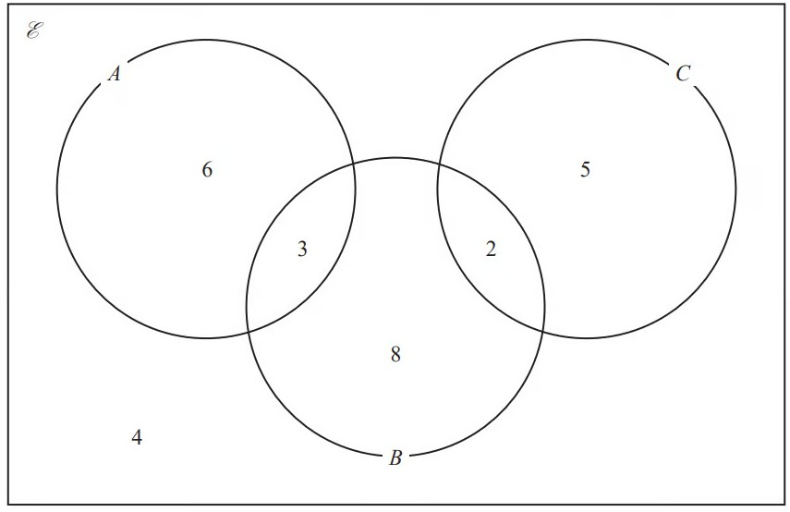

6, 3, 8, 2, 5 and 4 represent the numbers of elements.

Find

n(A ∪ B)

(1 mark)

- n(A ∩ B)

(1 mark)

- n(B ∩ C')

(1 mark)

- n(A' ∪ B' ∪ C')

(1 mark)

6 ℰ = {4, 5, 6, 7, 8, 9, 10, 11, 12, 13, 14, 15}

A ∩ B = {5, 10, 15}

B'= {7, 8, 9, 11, 12, 13, 14}

A'= {4, 6, 7, 8, 14}

Complete the Venn diagram for this information.

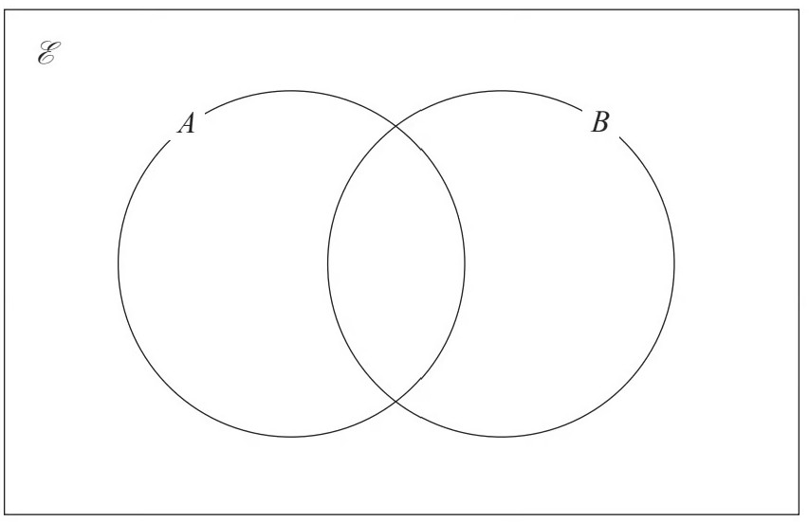

(3 marks)

Very Hard Questions
- (a) This year, 40 students have each travelled by one or more of plane (P), train (T ) or boat (
B).

- have travelled only by plane. 11 have travelled only by train. 9 have travelled only by boat.

n(P ∩ T) = 8 n(B ∩ T) = 3 n(B ∩ P) = 6
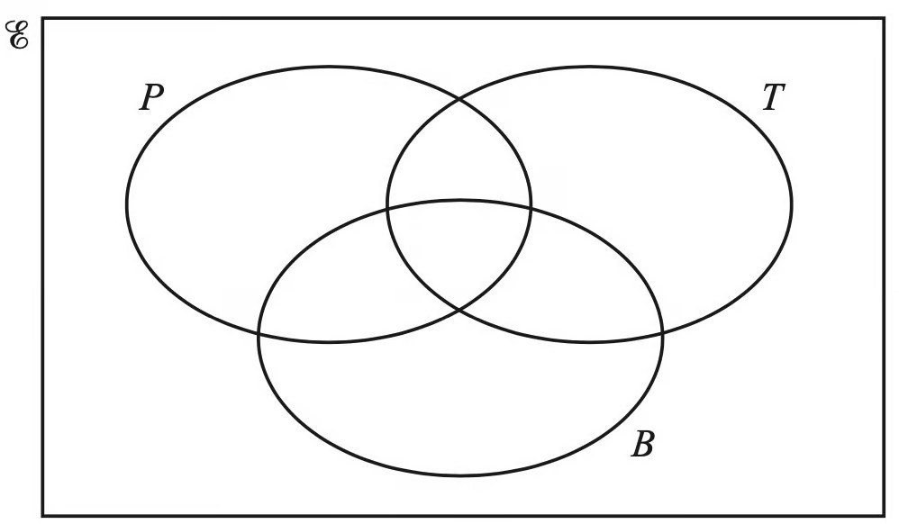
Complete the Venn diagram.

(3 marks)

- Find n((P ∪ B)') .

(1 mark)

- Use set notation to complete the statement.

(P ∪ T ∪ B)'= ...........................

(1 mark)

- (a)
50 students study at least one of the subjects geography (G), mathematics (M) and history (H ).
18 study only mathematics.
19 study two or three of these subjects. 23 study geography.

The Venn diagram below is to be used to show this information.

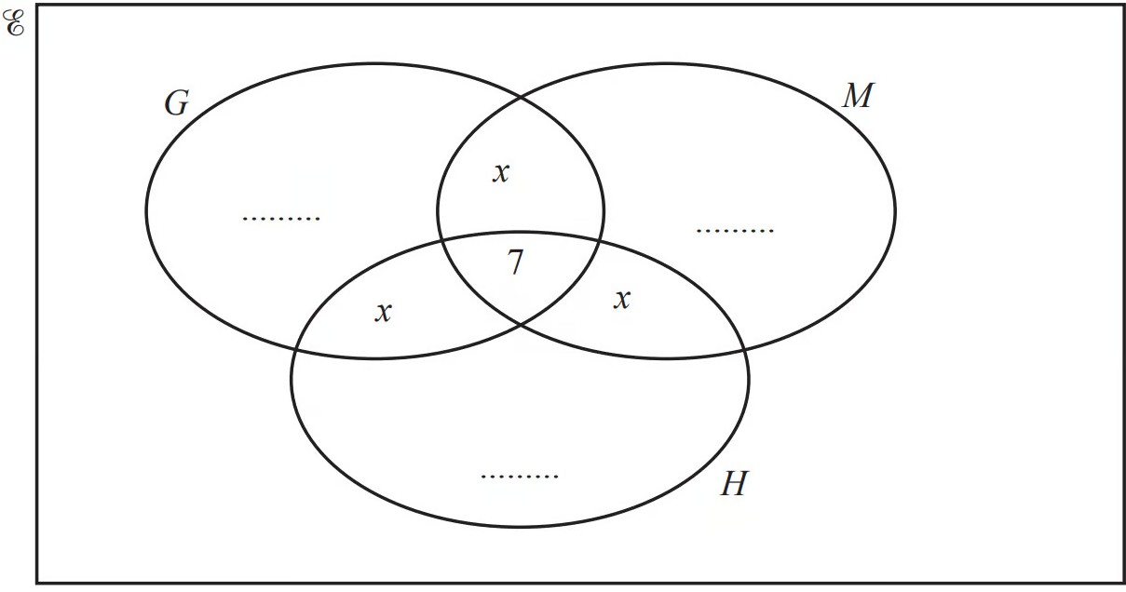
- Show that x = 4.

Complete the Venn diagram.
[2]

[2]

(4 marks)

(b) i) Use set notation to complete this statement.

(G ∪ M ∪ H)'= [1]

ii) Find n(G ∩ (M ∪ H)) .

[1]

(2 marks)

- (a) Some students in a school were asked the following question.

“Do you have a dog (D ), a cat (C) or a rabbit (R)?”

Of these students

28 have a dog 18 have a cat
20 have a rabbit
- have both a cat and a rabbit
- have both a dog and a rabbit
x have both a dog and a cat
6 have a dog, a cat and a rabbit
5 have not got a dog or a cat or a rabbit

Using this information, complete the Venn diagram to show the number of students in each appropriate subset.
Give the numbers in terms of x where necessary.

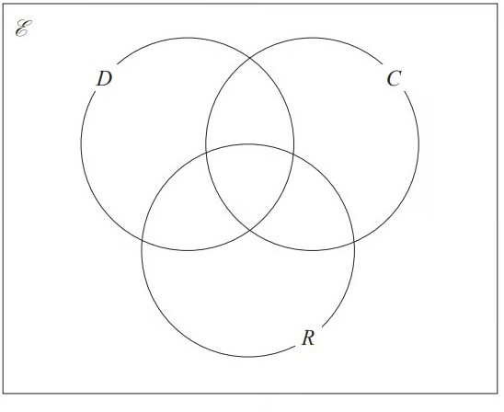

(3 marks)

- Given that a total of 50 students answered the question, work out the value of x .
x = ........................

(2 marks)

- Find n (C ʹ ∩ D ʹ )

(1 mark)

- (a) Some students were asked the following question.

“Which of the subjects Russian (R), French (F) and German (G) do you study?” Of these students
4 study all three of Russian, French and German 10 study Russian and French
13 study French and German 6 study Russian and German 24 study German
11 study none of the three subjects
the number who study Russian only is twice the number who study French only.

Let x be the number of students who study French only.

Show all this information on the Venn diagram, giving the number of students in each appropriate subset, in terms of x where necessary.

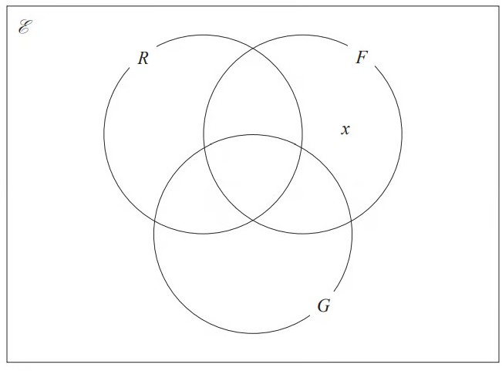

(3 marks)

(b) Given that the number of students who were asked the question was 80, work out the number of these students that study Russian.

(3 marks)

- (a) A and B are two sets. n(ξ) = 37
n(A) = 22
n(A ∩ B) = 12 n(A ∪ B) = 30

Complete the Venn diagram to show the number of elements in each region.

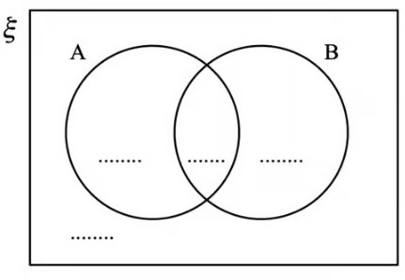

(2 marks)

  - Find

    - n(A ∩ B′)

[1]

    - n(A′ ∪ B′)

[1]

(2 marks)

