IGCSE CIE Maths  41 mins  23 questions
Non-Calculator Questions

Set Notation & Venn Diagrams
Set Notation & Venn Diagrams

Easy (6 questions) /7

Medium (7 questions) /19

Hard (7 questions) /12

Very Hard (3 questions) /3

Total Marks /41

Scan here to return to the course
or visit savemyexams.com
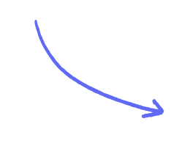

Easy Questions

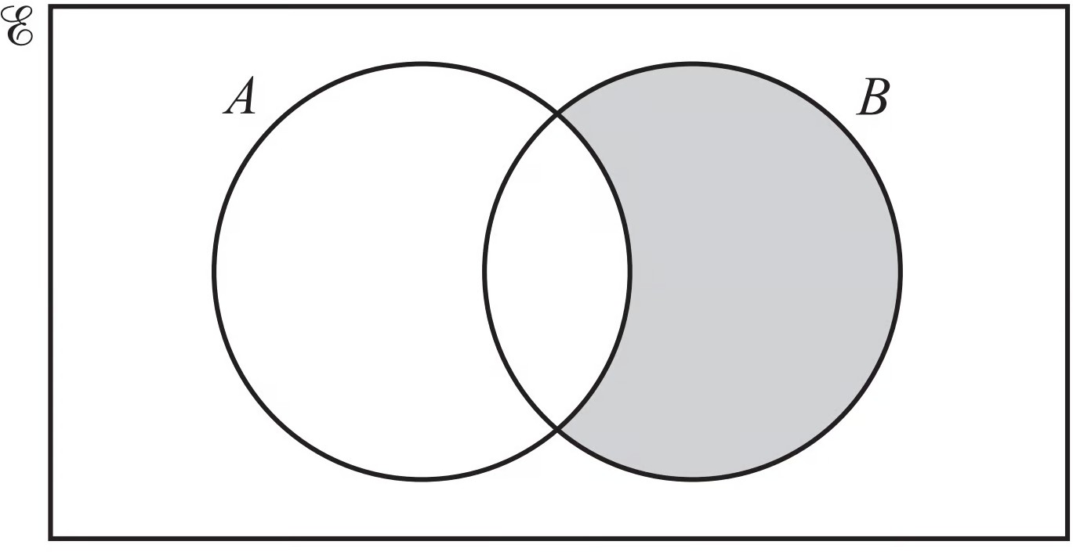
- Use set notation to describe the shaded region.

(1 mark)

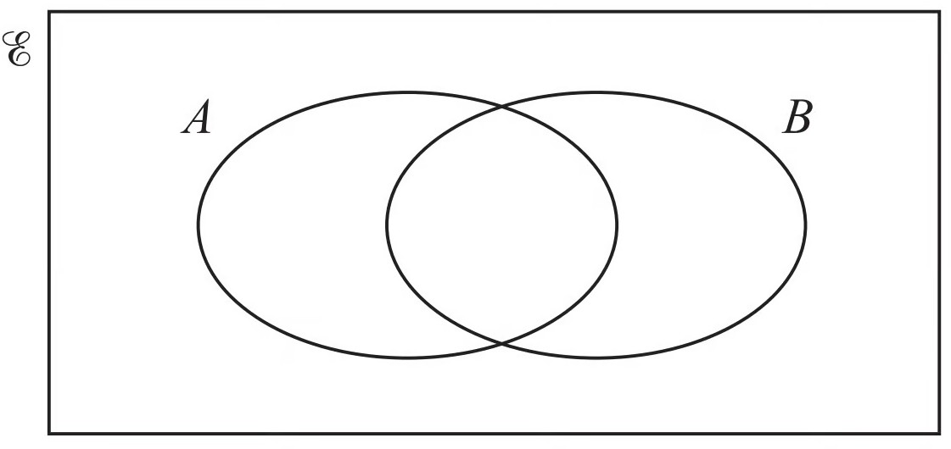

- On the Venn diagram, shade the region A ∩ B.

(1 mark)

- Shade the region A'∪ B in the Venn diagram below.

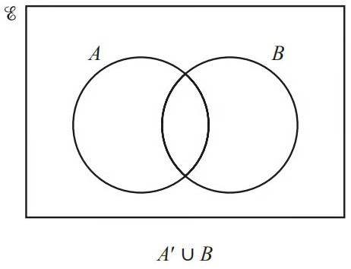

(1 mark)

- On the Venn diagram, shade the region (A ∩ B)'.

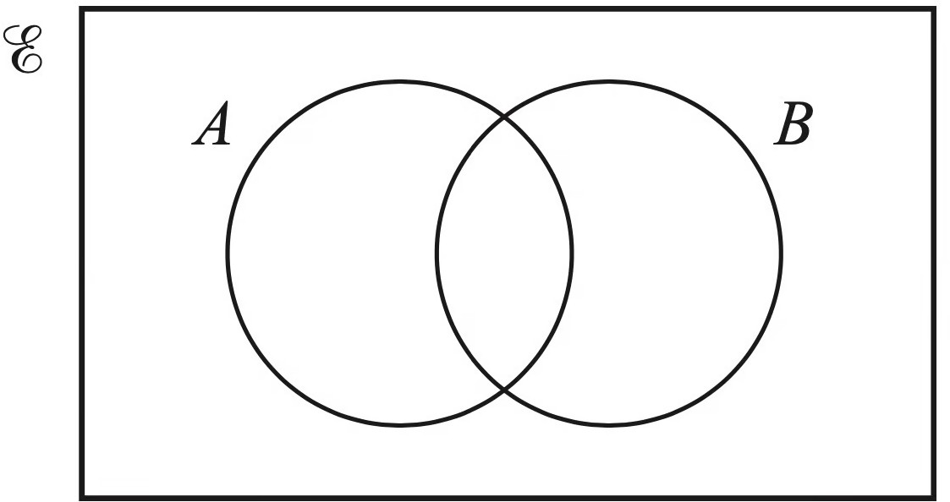

(1 mark)

- In the Venn diagram, shade X ' ∩ Y .
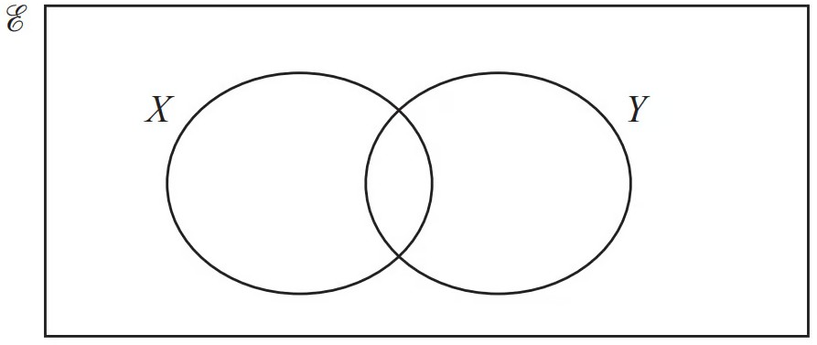

(1 mark)

- ℰ = {20, 21, 22, 23, 24, 25, 26, 27, 28, 29}

A = {odd numbers}

B = {multiples of 3}

List the members of the set

i) A ∩ B

ii)

A ∪ B
[1]

[1]

(2 marks)

Medium Questions

1 In a class of 40 students:

28 wear glasses (G )
13 have driving lessons (D )
4 do not wear glasses and do not have driving lessons.

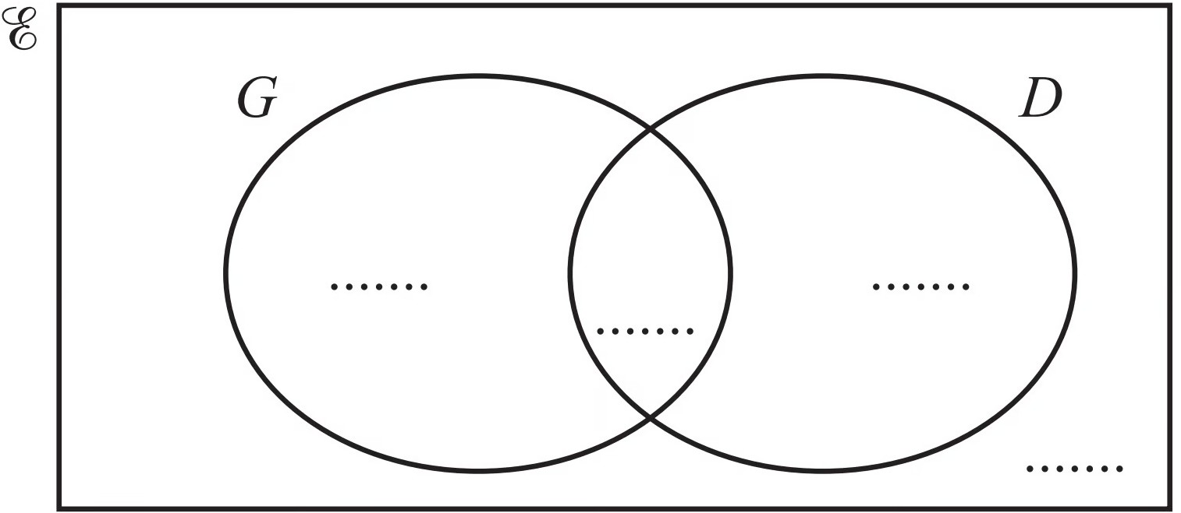

i) Complete the Venn diagram.

ii)

Use set notation to describe the region that contains a total of 32 students.
[2]

[1]

(3 marks)

2 ℰ={0, 1, 2, 3, 4, 5, 6} A ={0, 2, 4, 5, 6} B ={1, 2, 5}

Complete each of the following statements.

A ∩ B ={ }

n(B) = . . . . . . . . . . . . . . . .
{0, 4, 6} = . . . . . . . . . . . . . . . . ∩ . . . . . . . . . . . . . . . .
{2, 4} A

(4 marks)

- M ={x: x is an integer and 2 ≤ x < 6}
  - Find n(M) .

Write down a set N where N ⊆ M and N ≠ ∅ .
[1]

{ } [1]

(2 marks)

- 40 children were asked if they have a computer or a phone or both. The Venn diagram shows the results.

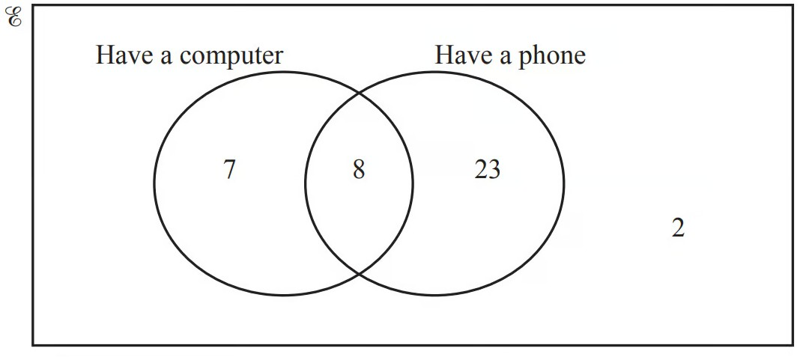

Complete the Venn diagram.

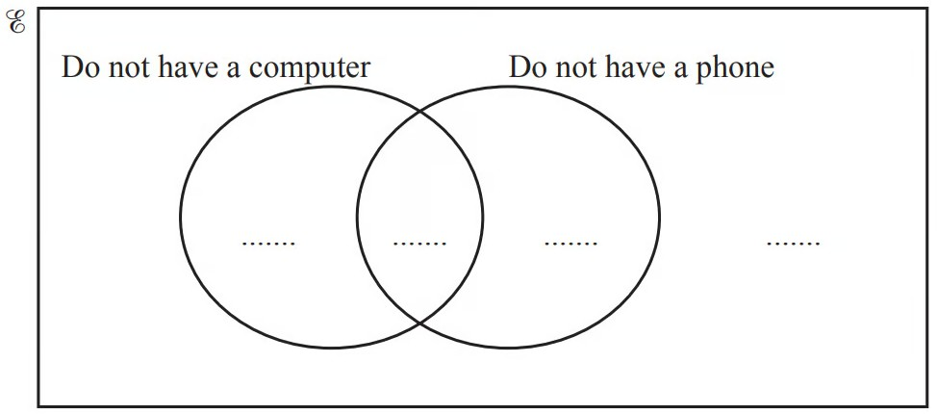

(2 marks)

- (a) C ={x : x is an integer and 5 < x < 12} D ={5,10}

Select the correct statement from the list below.

D = ∅ C ∩ D ={10} 6 ∈ D D ⊆ C

(1 mark)

(b) Find n(C ∪ D) .

(1 mark)

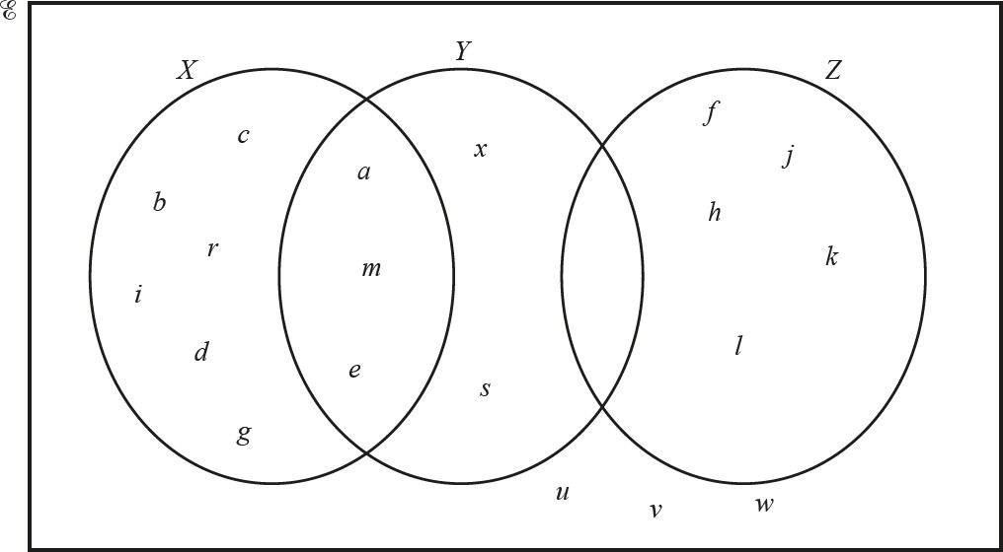
- Use set notation to complete the statements for the Venn diagram above.
  - c X
[1]
  - = {a, m, e}

[1]
  - Y ∩ Z = ..................................
[1]

(3 marks)

- The Venn diagram shows a universal set, ℰ and sets A, B and C.
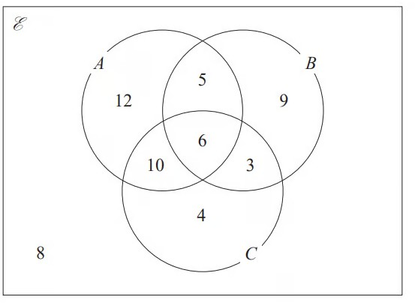

12, 5, 9, 10, 6, 3, 4 and 8 represent the numbers of elements. Find

i)

ii)

iii)
n (A ∪ B)

n (A ʹ ∩ B ʹ )

n ([A ∩ B] ∪ C)

[1]

[1]

[1]

(3 marks)

Hard Questions

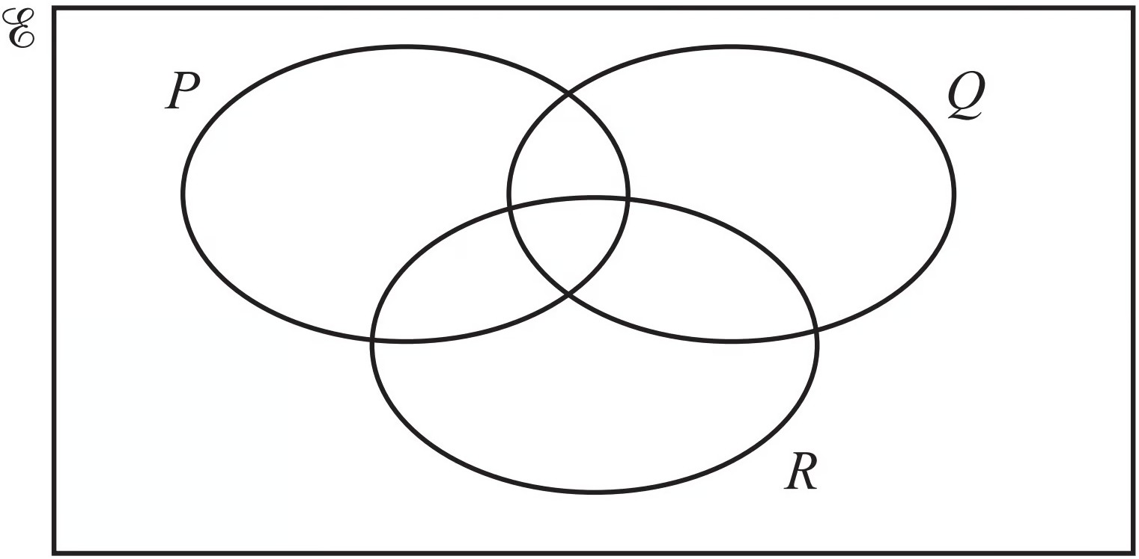
- Shade the region P ∪ (Q ∩ R)'.

(1 mark)

- Shade the region (D ∩ E)' ∩ F in the Venn diagram below.

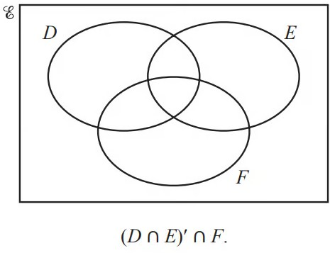

(1 mark)

- In each Venn diagram, shade the required region.

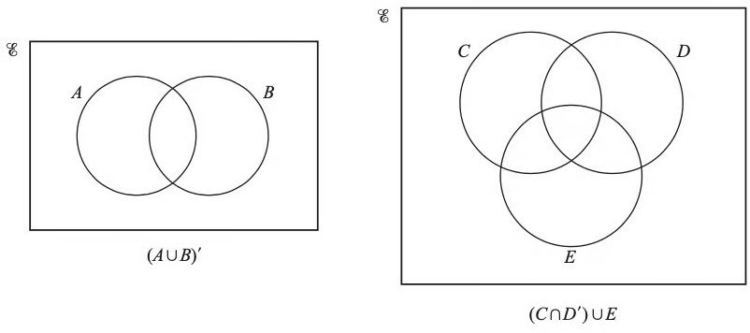

(2 marks)

- In this Venn diagram, shade the region (A ∪ B') ∩ C .
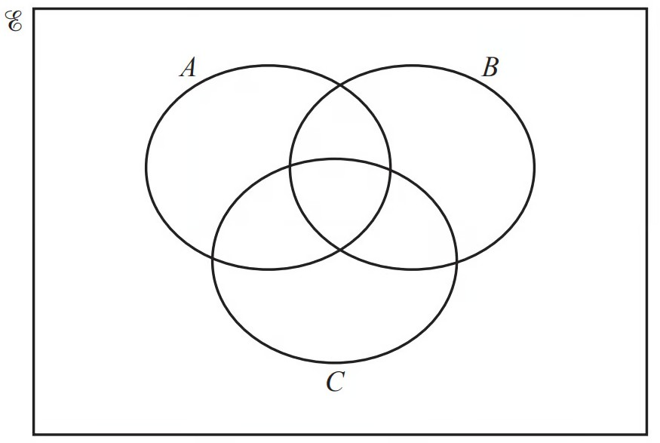

(1 mark)

- The Venn diagram shows information about the number of elements in sets A, B and ℰ
.

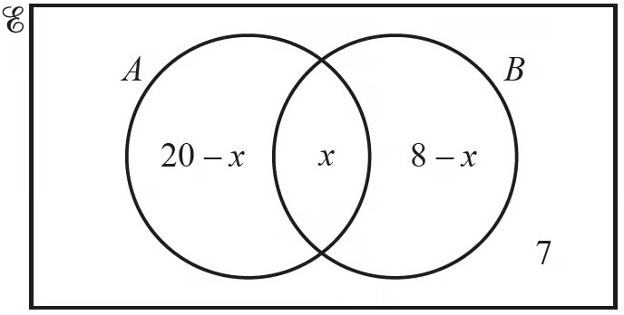

n(A ∪ B) = 23
Find the value of x .

x = ................................................

(3 marks)

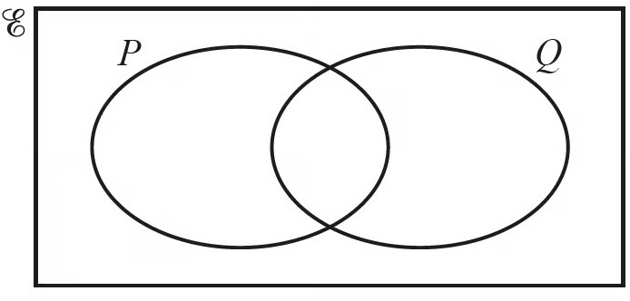

- n(ℰ) = 20, n= (P) 10, n(Q) = 13 and n(P ∪ Q)'= 5.

Work out n(P ∩ Q) .
You may use the Venn diagram to help you.

n(P ∩ Q) = ................................................

(2 marks)

- (a) List the elements of (X ∪ Y ∪ Z)'.

(1 mark)

(b) Find n(X'∩ Z) .

(1 mark)

Very Hard Questions
- In this Venn diagram, shade the region M '∪ N ∪ P .
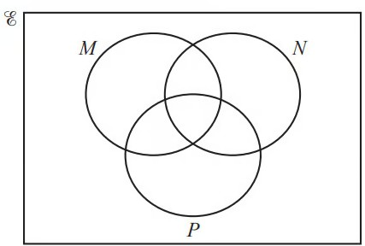

(1 mark)

- This Venn diagram shows information about the number of students who play basketball
(B) , football (F) and hockey (H) .

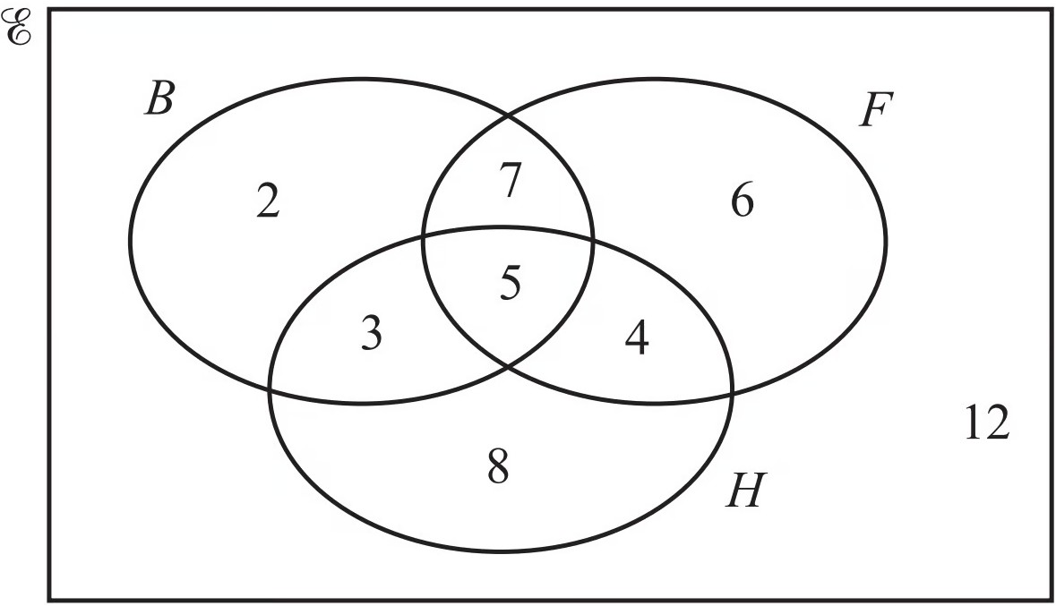

Find n((B ∪ F) ∩ H') .

(1 mark)

- The Venn diagram below shows information about the number of gardeners who grow melons (M ), potatoes (P ) and carrots (C ).
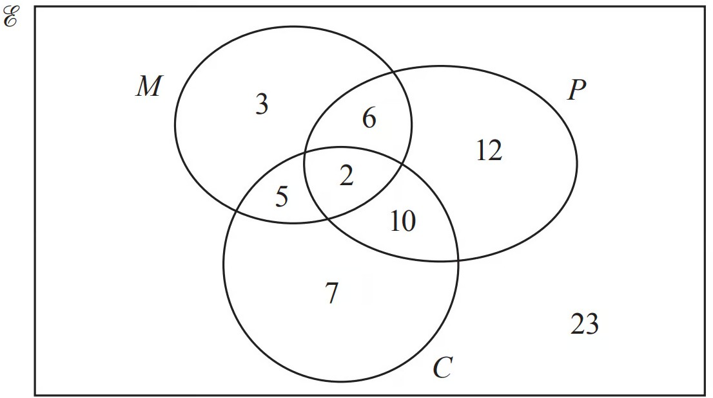

Find n((M ∩ P) ∪ C') .

(1 mark)

